1. **Map the protocol at the left side with the problem that it solves on the right by drawing arrows or lines – 10 pts**

|  |  |
| --- | --- |
| _e_CRC 32 | 1. Hidden Terminal |
| _a_CSMA/CA | 1. Prevents Loop |
| _g_FDM/TDM | 1. Reliable Transfer |
| _j_Bit and Byte Stuffing | 1. Collision Detect |
| _c_Sliding Window | 1. Error Detection |
| _d_CSMA/CD | 1. Enables parallelism |
| _b_Spanning Tree | 1. Resource Sharing |
| _h_NRZI | 1. Encoding |
| _i_FTP/NFS | 1. File Access |
| _f_ATM | 1. Framing |

**2. Determine the following statements if they are true or false. Right T (True) or F (False) on the Left Blank space. – 5 pts**

2.1 ___FALSE___ Parity bit can catch all errors in a bit stream

2.2 __FALSE____ We can always represent a network as a loop free graph

2.3 __TRUE____ 4B/5B implements does not care about Consecutive 1s

2.4 __FALSE____ It is beneficial to have Larger receiving window than the Sending window in Sliding Window Protocol

2.5 ___TRUE___ Spanning tree algorithm finds out the shortest route to any destination in the network while eliminating the loops.

3. Answer the following seven questions. – 20 pts

3.1 If a switch did not know where to forward a frame, what do you think it would do? – 2 pts

It would flood the frame to all other ports by inserting the Mac Address into the table. Therefore, forward the frame to all ports.

3.2 What is the hidden terminal problem and how do we solve it? – 3 pts

The hidden terminal issue is when two nodes can’t communicate or see each other but are “connected” by a node in between and can communicate to it at the same time. Use CSMA/CA because it has 802.11 which has RTS and CTS packets that can talk to the receiver, which solves the issue of the nodes being hidden.

3.3 What would happen if you have two nodes with the same ID in a spanning tree? – 3 pts

This would cause an error. Two nodes are not to have the same ID.

3.4 What is an example application that runs on the Internet where a circuit switched dedicated path makes more sense than a packet switched network? – 3 pts

Telephone lines use a dedicated connection in analog telephones. There may be other examples like military or hospital use that makes sense if it needs to be more reliable or secure.

3.5 What do you think happens when both the data bits and parity bits are corrupted? – 3pts

If both the parity bit ad data bit is corrupt, then the parity bit will not catch the error and the data will be corrupted without detection.

3.6 Write three differences between CSMA/CA and CSMA/CD – 3 pts

CSMA/CA is used for wireless, while CSMA/CA is used for wired.

CSMA/CA is used for collision avoidance or beforehand, while CSMA/CD is useful for when it happens or after hand.

CSMA/CA minimizes risk, while CSMA/CD helps with recovery time.

3.7 Circuit switching can support more users than packet switching with the same number of resources. Why or why not? – 3 pts

Circuit switching can’t support more users than packet switching because circuit switching is limited in number when it comes to connections, so it may not use all bandwidth available.

**4. For each of the following operations, mention if you should be concerned about delay,  
bandwidth, or jitter (the answer may be a combination of these)? – 5 pts**

a) Remote login: Delay, Jitter

b) Very large file transfers: Bandwidth

c) Interactive gaming: Delay, Jitter, Bandwidth

d) Web browsing: Bandwidth

e) Video conferencing: Delay, Jitter, Bandwidth

**5. Imagine the following scenario: a phone is downloading a 100MB (1KB = 1024 bytes) video from a computer. The connection setup between the phone and the radio tower is 5 RTT. You may assume the rest of the infrastructure is already connected. Transmission rate of all links are 100Mbps (1Mb = 1024Kb), and distance of each hop is 30KM. The speed of the signal is 300,000KM/sec. Assume no queuing delay. – 20 pts**

Data size = 100MB  
Transmission rate: 100Mbps  
Distance of each link – 30KM, Speed of Signal – 300,000KM/sec (See next page...)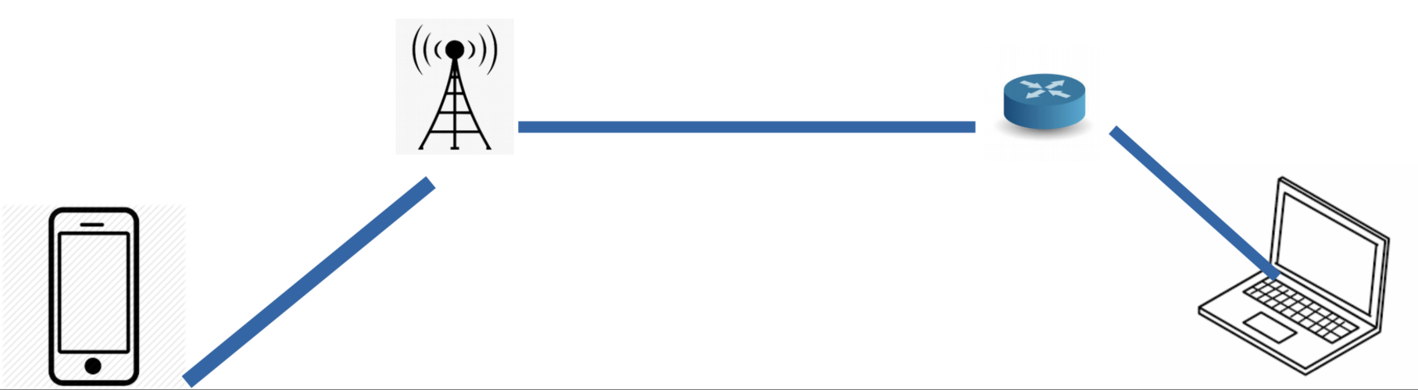

1. What is the total end-to-end delay? Explain in one sentence how you calculated it. **10 Pts**

**1 RTT = Transmisson Time + 2 * Propagation Time**

**Distance / Time = 30 Km / 300,000 Km/s = 0.0001**

**1 RTT = 2*(0.0001 * 4) = 0.0008s**

**5 RTT = 5 * 0.0008 = 0.004s**

**Packet TT = length / bandwidth = 100*1024*1000*8 / 100*1000*1000 = 8.192s**

**Total = 8.192 + 0.0008 + 0.004 = 8.1956s**

1. What is the total delay if the link between the phone and the radio tower loses all data for two seconds and the server re-transmits them? Explain in one sentence how you calculated it. **10 pts**

**Total End to End + 2 seconds**

**8.192 + 2 = 10.192s**

**6. Assume you are connecting two machines over a network with 100Mbps bandwidth and 30ms round-trip time. If the sender always sends at the full capacity of the network and never stops, how many bytes are “in-flight” through the network at any given time? - 5Pts**

**In-flight = RTT**

**Bandwidth Delay = Bandwidth * RTT**

**= (100 Mbps * 10^6 bits/s * 30ms * 10^-3s)/8**

**= 375Kb = 375,000 bytes**

**You take the bandwidth and multiply by RTT to get Bandwidth delay, then you will need to turn into bits then final answer in Bytes.**

**7. Circle the errors (flipped bits) in this 2-d parity table (odd parity). 5 pts**

|  |  |  |  |  |  |
| --- | --- | --- | --- | --- | --- |
| 1 | 1 | 0 | 0 | 0 | 1 |
| 0 | 1 | 1 | 0 | 1 | 1 |
| 1 | 1 | 0 | 0 | 0 | 0 |
| 1 | 0 | 1 | 0 | 1 | 0 |
| 1 | 1 | 0 | 0 | 1 | 0 |
| 1 | 1 | 0 | 1 | 1 | 0 |

**8. In the Ethernet transmitter algorithm, once an adaptor has detected a collision, it waits a  
certain amount of time and tries again. After the fifth collision, what is the probability that a node chooses K=8? (Hint: Exponential Backoff) – 5 pts**

**K= 8 = 1/32 = 0.03**

**9. In the question above, the result K=8 corresponds to a delay of how many seconds on a 10 Mbps Ethernet? – 5 pts**

**Delay = K * 512 * Bit Times**

**Bit Times for 10Mbps = 0.1 microseconds**

**= 8 * 512 * 0.1 = 409.6 microseconds = 0.04096s**

**10. Suppose you are designing a sliding window protocol for a 10-Mbps point-to-point link to the moon, which has a one-way latency of 1.25 seconds. Assuming that each frame carries 10 KB of data, and SWS = RWS (Sender window size is equal to the receiver window size) what is the minimum number of bits you need for the sequence number? – 10 pts**

**\*\*\*Use- 1Mbps = 1024Kbps, and 1KB = 1024 Bytes**

(Hint: Compute RTT, Delay*Bandwidth, determine number of frames required, to keep the pipe full)

Sender Window Size = Receiver Window Size

Window size = (Bandwidth * RTT) / Frame Size

= (10 * 1024 * 1024 * 2 * 1.25) / 10 * 1024 * 8

= 320 Frames

SWS = RWS so 320 * 2 = 640 frames

2^10 = 1,028 Frames which is the minimum possible

= 10 bits

**11. Given the LAN below, which ports are *not* selected by the spanning tree algorithm? Draw your generated spanning tree from the below graph – 5 pts**

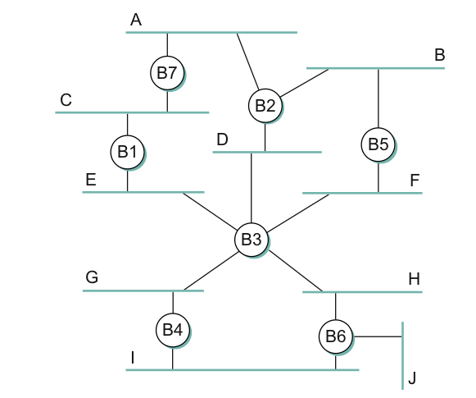

The spanning tree algorithm works as follows:

* Lowest ID is root
* Root sends out frames over all ports
* Each bridge computes the shortest path to root and notes the port
* All bridge connected to a LAN elect a single bridge that is closest to the root
* If a bridge is connected to two LANs they participate in both elections

In case of a tie, lower id wins

B2, B5, and B6 can create a loop so they will not be chosen by the algorithm.

**12. Draw a timeline diagram for the sliding window algorithm with SWS=RWS = 5 frames that shows the loss of the second and the third frame. You may use a timeout interval of 2RTT. – 5pts**

